SLIIT

SE3082 – Parallel Computing



REPORT 05

Heshanth T
IT24101633

Exercise 04 Report
Question: Briefly describe how the threads are generated for this code, and how they are generated when replaced with collapse(2). Answer: - Without collapse: Only the outermost loop (r from 1 to 5) is parallelized. This means a maximum of 5 threads can effectively be used. - With collapse(2): Both the r and k loops are collapsed into a single iteration space of 5 * 10 = 50 iterations, distributed among all available threads for better load balancing.
Screenshot (Without Collapse): 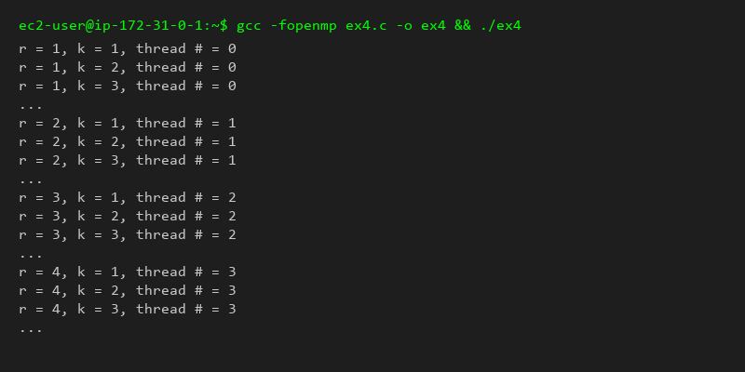
Screenshot (With Collapse): 